EXIT TICKET
1 Match the words to the pictures of different materials.

ID: 213113362 ID: 1096243748 ID: 743046340
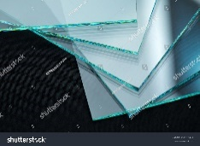
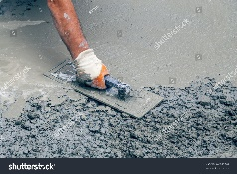
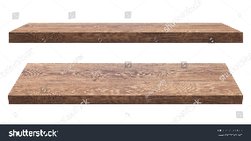

glass
concrete
leather
cotton
plastic
wood
brick

ID: 595022984 ID: 462908386 ID: 617507069 ID: 394362211
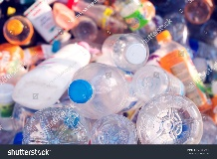
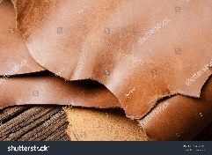
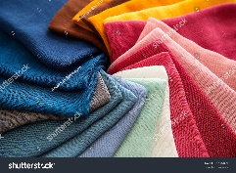
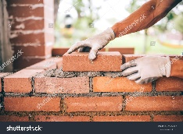

2 Complete the sentences.
1) Leather comes from animals like ___________________________________________________ .
2) T-shirts are made of ________________ .
3) Windows and mirrors are made of ____________________ .
5) We can recycle ________________________________________ .
6) Wood comes from _________________ . It can be used to make ____________________________ .

